Date :

Child’s surname :
Child’s name :
Birth date : |  |  | Birth sex : |  | F ☐ M ☐ | Gender :
Address :
School/Nursery : |  |  |  | Pediatrician :
Phone number 1 : |  |  |  | Phone number 2 :
I agree to receive appointment reminders by SMS : No ☐ Yes ☐ Phone number : 1 ☐ or 2 ☐
Email address :
Health insurance : |  |  | Card number (20 digits) : 807560
Appointment recommended by :

Reason of the request (symptoms, difficulties, specific problems,…) :
________________________________________________________________________________________________________________________________________________________________________________________________________________________________________________________________________________________________________________________________________________________________________________________________________________________________________________________________________________________________________________________________________________________________________________________________________________________________________________________________________

Current therapies/help :
☐ Psychologist (Name) : |  | ☐ Occupational therapist (Name) :
☐ Speech therapist (Name) : |  | ☐ Psychomotor therapist (Name) :
☐ SEI-SPS |  | ☐ Others :
☐ AI (OIC number) :
Mother tongue : |  | Other languages :
Please attach all relevant document (evaluation report, consultation report, school documents,…)
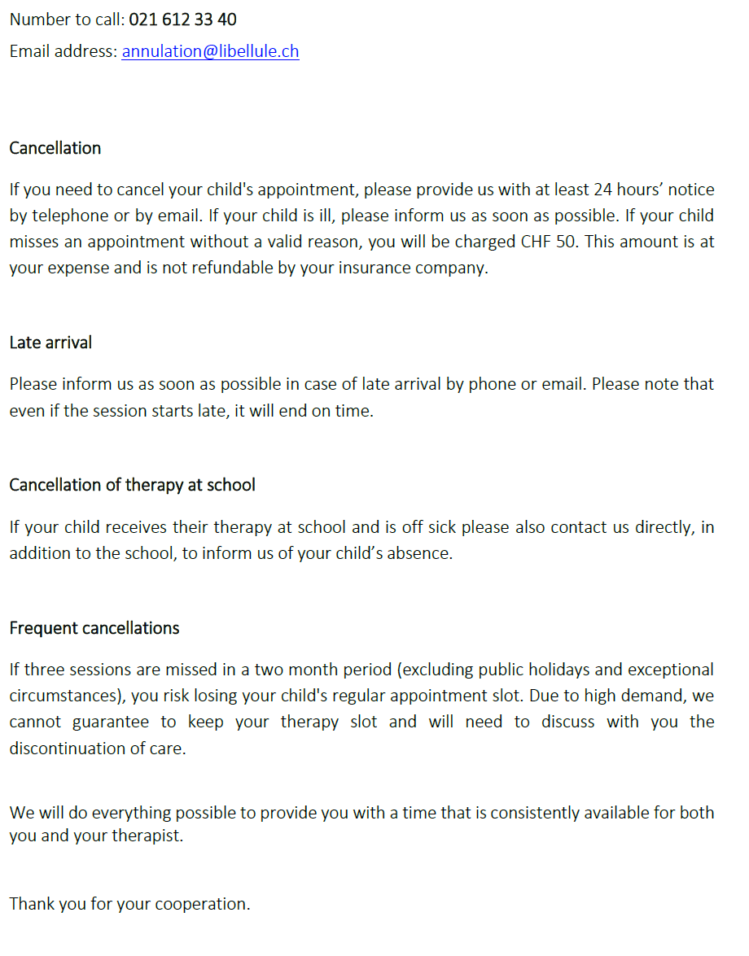
Cancellation Policy
v1.1 Sep. 2022

